**Experiment-3**

**AIM :** Familiarization of LINUX commands.

**CO2 :** Perform system administration tasks.

**PROCEDURE :**

1. **Pwd :** The pwd command is used to display the location of the current working directory. When you first open the terminal, you are in the home directory of your user. To know which directory you are in, you can use pwd command. It gives us the absolute path, which means the path that starts from the root. The root is the base of the Linux file system. It is denoted by a forward slash( / ). The user directory is usually something like "/home/username".

$ pwd

**OUTPUT:**



1. **ls :** The [ls](https://www.javatpoint.com/linux-ls) command is used to display a list of content of a directory. Use the "ls" command to know what files are in the directory you are in. You can see all the hidden files by using the command ls.

$ ls

OUTPUT:



1. **ls -R : ls -R** option will list very long listing directory trees.

$ ls -R

OUTPUT:

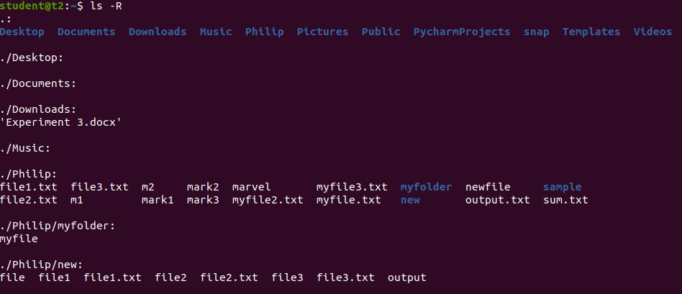

1. **ls -l : ls -l** shows file or directory, size, modified date and time, file or folder name and owner of the file, and its permission.

$ ls -l

OUTPUT:

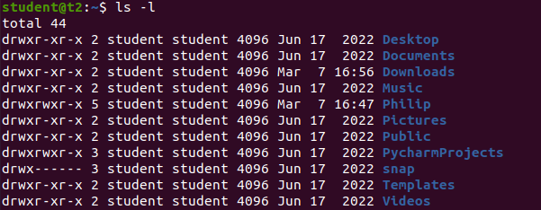

1. **ls -al : List all the files including hidden files in the current directory.**

**$ ls -al**

**OUTPUT:**

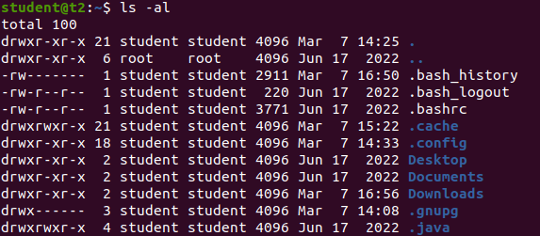

1. **ls -a :** List all files including hidden files starting with ‘.‘.

$ ls -a

OUTPUT:



1. **ls -t :** Sort the list by time of modification, with the newest at the top.

$ ls -t

OUTPUT:



1. **ls -r :** The following command with the **ls -r** option display files and directories in reverse order.

$ ls -r

OUTPUT:



1. **mkdir :** The [mkdir](https://www.javatpoint.com/linux-mkdir) command is used to create a new directory under any directory. The mkdir command allows you to create directories from within the terminal. The default syntax is **mkdir** followed by the directory name.

$ mkdir ann

OUTPUT:





1. **cd :** Use the cd command to go to a directory. Remember, this command is case sensitive, and you have to type in the name of the folder exactly as it is. But there is a problem with these commands. The [cd](https://www.javatpoint.com/linux-cd) command is used to change the current directory. To go back from a folder to the folder before that, you can type cd . The two dots represent back.

$ cd ann

$ cd..

OUTPUT:





1. **history :** Linux history command is used to display the history of the commands executed by the user. It is a handy tool for auditing the executed commands along with their date and time. This command is used to view the previously executed command.

$ history

OUTPUT:

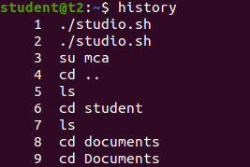

1. **man ls :** man ls command is used to learn and understand about different commands right from the shell.

$ man ls

OUTPUT:



1. **cat > :** The [cat](https://www.javatpoint.com/linux-cat) command is a multi-purpose utility in the Linux system. It can be used to create a file.

$ cat > filename

OUTPUT:

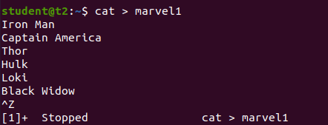

1. **cat :** The [cat](https://www.javatpoint.com/linux-cat) command is a multi-purpose utility in the Linux system. It can be used to display content of the file.

$ cat filename

OUTPUT:

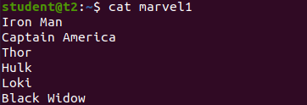

1. **cat >> :** The [cat](https://www.javatpoint.com/linux-cat) command is a multi-purpose utility in the Linux system. It can be used to append the content of the file.

$ cat >> filename

OUTPUT:

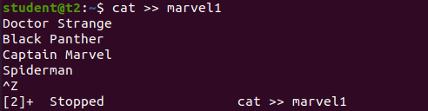

1. **cat -n :** cat -n is used to display the line numbers.

$ cat -n filename

OUTPUT:

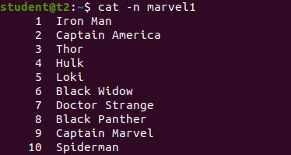

1. **cat -b :** cat -b is used to remove the numbering of empty lines.

$ cat -b filename

OUTPUT:

